Docker Workflow Documentation

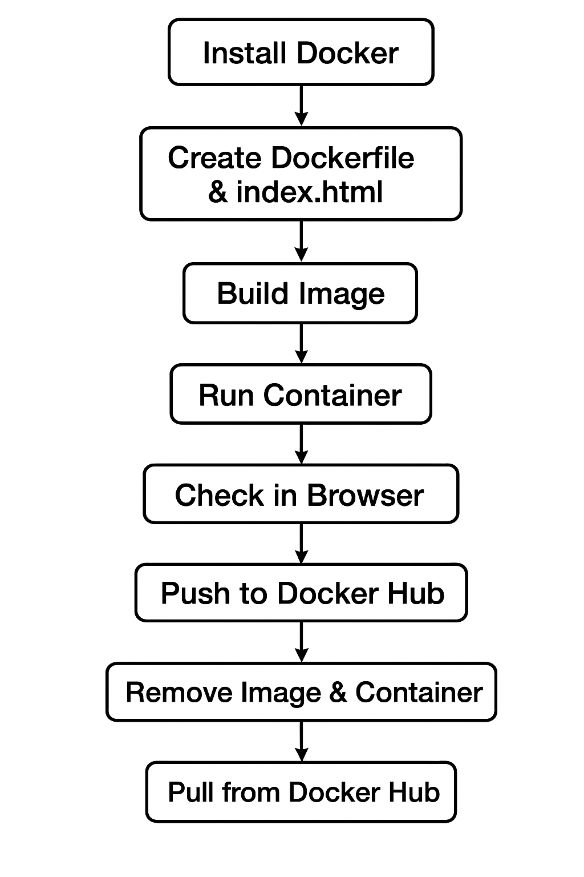

1️⃣ Install Docker on Linux (CentOS/RHEL/Amazon Linux)

# Update system
sudo yum update -y
# Install required packages
sudo yum install -y yum-utils device-mapper-persistent-data lvm2
# Add Docker repository
sudo yum-config-manager --add-repo https://download.docker.com/linux/centos/docker-ce.repo
# Install Docker
sudo yum install -y docker-ce docker-ce-cli containerd.io
# Start and enable Docker
sudo systemctl start docker
sudo systemctl enable docker
# Verify Docker installation
docker --version

2️⃣ Create Project Directory & Files

# Go to home or desired directory
cd ~
mkdir mysite
cd mysite
# Create Dockerfile
vi Dockerfile

Dockerfile content

FROM nginx:alpine
COPY index.html /usr/share/nginx/html/
EXPOSE 80
CMD ["nginx", "-g", "daemon off;"]

Creating index.html

# Create index.html
vi index.html

index.html content

<!DOCTYPE html>
<html>
<head>
<title>My Nginx Site</title>
</head>
<body>
<h1>Hello from Docker Nginx!</h1>
</body>
</html>

3️⃣ Build Docker Image

# Build image with tag "mysite"
docker build -t mysite .
# Verify image
docker images

4️⃣ Run Container

# Run container in detached mode and map port 8080
docker run -d -p 8080:80 mysite
# Verify running container
docker ps

5️⃣ Test in Browser or via Curl

# From EC2 itself
curl http://localhost:8080
# From browser
http://<EC2-Public-IP>:8080

✅ You should see:

Hello from Docker Nginx!

6️⃣ Push Image to Docker Hub

Step 6a — Login to Docker Hub

docker login
# Enter username & password

Step 6b — Tag the image

docker tag mysite <dockerhub-username>/mysite:v1
# Example:
docker tag mysite imrankhanmohammad257/mysite:v1
Step 6c — Push to Docker Hub

docker push imrankhanmohammad257/mysite:v1

7️⃣ Remove Local Image & Container

# Stop running container
docker stop <container_id>
# Remove container
docker rm <container_id>
# Remove local image
docker rmi mysite
docker rmi imrankhanmohammad257/mysite:v1

8️⃣ Pull Image from Docker Hub (any system)

# Login if repo is private
docker login
# Pull image
docker pull imrankhanmohammad257/mysite:v1
# Run container from pulled image
docker run -d -p 8080:80 imrankhanmohammad257/mysite:v1
# Verify
docker ps
curl http://localhost:8080

✅ This completes the full Docker workflow: install, Dockerfile creation, build, run, test, push to Docker Hub, clean up, and pull from Docker Hub.

